University Content

# Purpose

The Content Interface is designed to help with the creation and maintenance of learning materials for University courses. Consequently, the Content Interface offers functionality to help support learning in University courses. The following table provides a summary of that functionality with the following sections offering more detail.

|  |  |
| --- | --- |
| **Label** | **Description** |
| Readings | Visually distinguish descriptions of readings learners should undertake. |
| Activities | Visually distinguish activities learners should perform. |
| Note | Visually distinguish important information that learners should take note of. |
| Aside | Represent information that is indirectly related to the main content. A slightly toned-down version of *Note*. |
| Indent | Indent some text, without any additional styling |
| Poem | Used to display poems. Text is indented and has a shaded background |
| FAQs | Two styles (FAQ Question and FAQ Answer) |
| University Dates | Enable the automatic insertion of a specific date into generic date descriptions - e.g. *Monday, Week 5* becomes *Monday, Week 5 (20 August, 2020)* – based on the trimester or study period for the specific course site. |
| Film Watching Options | Automatically translate the name of a film into specific instructions for how learners may watch the film. |

# Activity

An activity will be displayed on the web in a way different to a reading. However, you specify an activity much the same way. Create the text and then apply the *Activity* style to it. As seen below, the *Activity* style has a different background colour (blue) to highlight the different style.

### What it looks like in Word

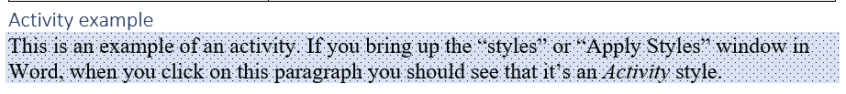

Figure - Example of activity style as it appears in Word

### What it looks like on the Web

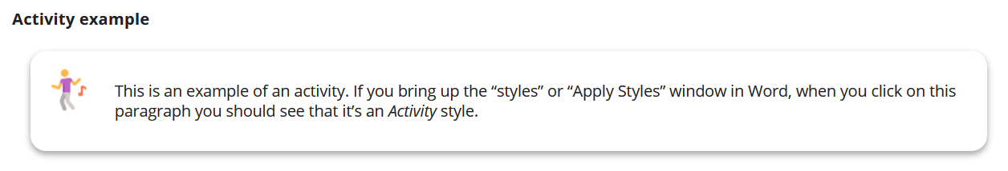

Figure - Example activity style as it appears on the Web

# Note

Any text that has the *Note* style applied will appear currently in a quite obvious warning box when displayed online (and yellow background when displayed in Word).

### What it looks like in Word

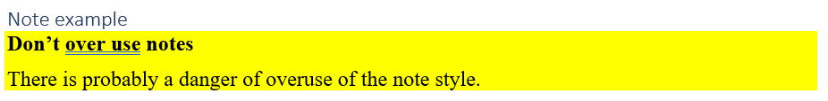

Figure - Note style example as shown in Word

### What it looks like on the Web

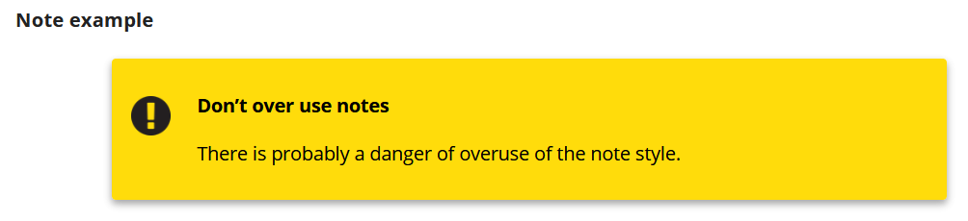

Figure - Note style example as shown on the Web

# Aside

The *Note* style can be a little extreme for some purposes. Sometimes you just want to add something that is indirectly related to the content. Useful to highlight but not a warning. A purpose that fits the *Aside* style.

### What it looks like in Word



Figure - Aside style example as shown in Word

### What it looks like on the Web

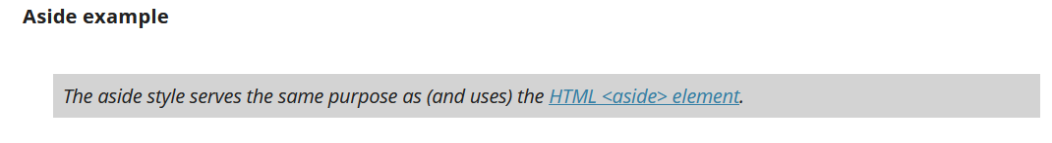

Figure - Aside style example as shown on the Web

# Reading

If you want to have something appear as a reading that is clearly separate from the rest of the text then apply the *Reading* style. As I’ve done with the following content. Not the different background colour that is part of the *Reading* style. This change in colour is used to more clearly indicate what is or is not a reading.

Current practice is to have a title for the reading (or activity that is not styled *Reading*). As shown below.

### What it looks like in Word

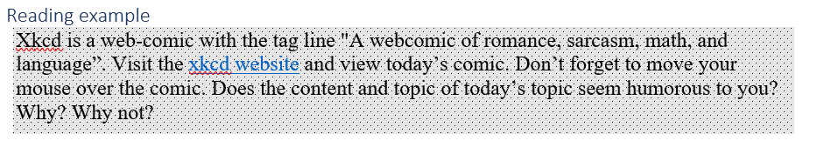

Figure - Reading style example as shown in Word

### What it looks like on the Web

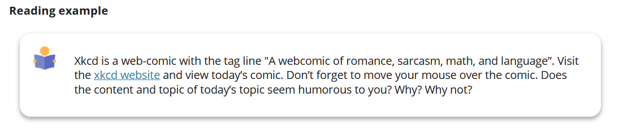

Figure - Reading style example from the Web

# Poem

Some courses wish to display poems in a visually distinct way. The *Poem* style provides one method.

### What it looks like in Word

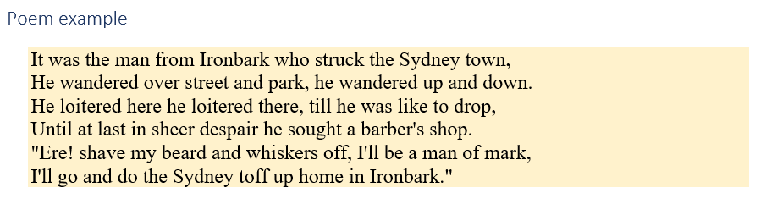

Figure - Poem style example as shown in Word

### What it looks like on the Web

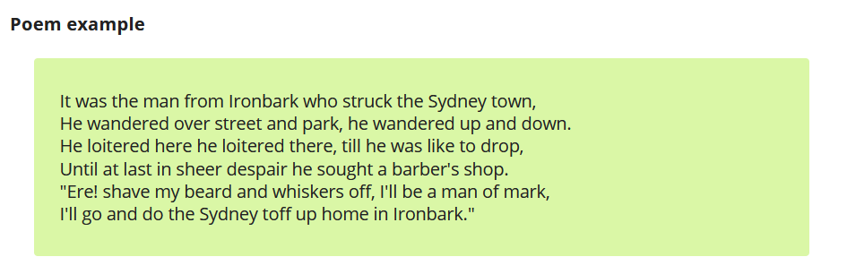

Figure - Poem style example as it appears on the Web

# FAQs

Providing Frequently Asked Questions (FAQs) is a common requirement. FAQs can be displayed in a variety of ways. Explicit support for FAQs is provided by two styles:

1. FAQ Question – defines the question or header.
2. FAQ Answer – defines the answer.

### What it looks like in Word

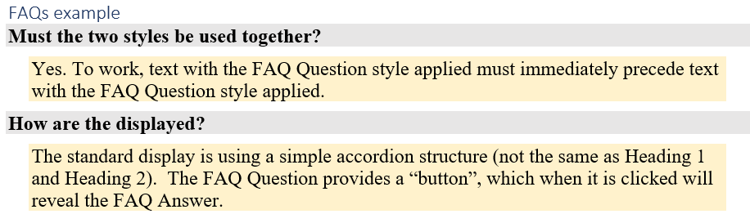

Figure - FAQ Question and FAQ Answer styles in Word

### What it looks like on the Web

As suggested in Figure 12 initially only the questions (the text styled with the *FAQ Question* style) appear. To view an answer (the text styled with the *FAQ Answer* style) the visitor clicks on the question. Clicking on the question again causes that answer to be hidden.

Only one answer at a time is displayed.

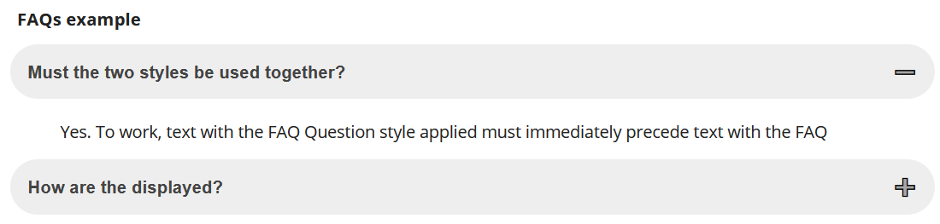

Figure - FAQ Question and FAQ Answer styles on the Web

# University Dates

If you wish to include the date for an assignment you might write

Assignment 1 due 5pm on Wednesday Week 5 (17 March 2019).

**Problem:** What happens when your course content gets rolled over into another trimester or study period? A study period that has different dates. Almost certainly Wednesday Week 5 will no longer be 17 March 2019.

The solution to this problem is to use the *University Date* style to tell the Content Interface to insert a date specific to the course’s current trimester/study period.

### What it looks like in Word

Figure 13 shows numerous examples of the *University Date* style being used in Word. Any text shown in red has had the *University Date* style applied to it. When viewed on the web a specific calendar date will be inserted in braces after the date string. The date will be based on the teaching period for the current course site.

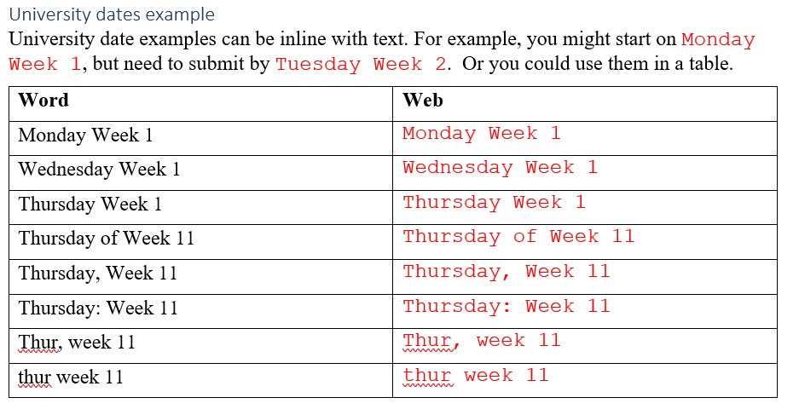

Figure - Examples of the University Date style as shown in Word

**Note:** As shown in Figure 13, there is some flexibility in how the date string is written. Flexibility includes:

* the case (upper or lower) is used for the letters;
* the day is written (in full or abbreviated); and,
* how the day and week are separate (by a space; by the word *of*, or by a: comma, semi-colon, colon, hyphen or dash)

### What it looks like on the Web

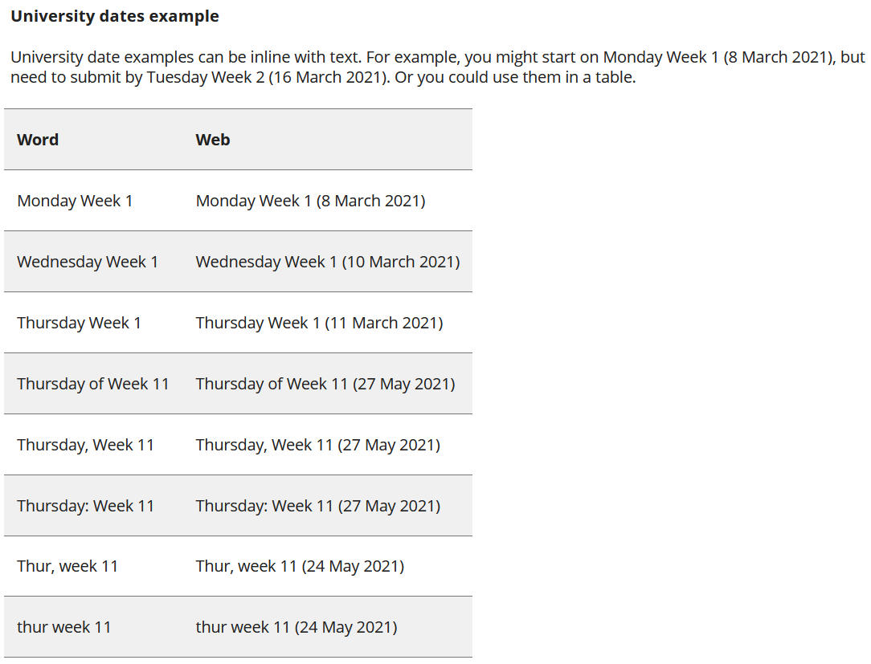

Figure - What examples of the University Date style from Figure 13 look like on the Web

## How to do it

1. Write out the date using the format - *Day* Week *NumWeek*  
   Where *Day* is replaced by a day of the week (capitalisation not important) and *NumWeek* is replaced by a number representing the week of the trimester/study period.  
   e.g. Thursday Week 4
2. Apply the *University Date* style to the date you wrote.   
   In a Word document based on the right template, the date text should be red in colour and use the Courier New font. The change in font and colour is intended to help you recognise the difference when editing the Word document.

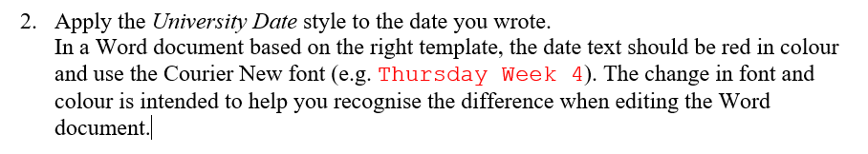

Figure 15 - What it looks like in Word

# Film Watch Options

In a small number of courses learners are required to watch numerous films. The Griffith University Library provides [methods by which learning resources](https://www.griffith.edu.au/library/teaching#resources-for-teaching) – such as films – can be sourced for use in courses.

**Problems:** While many films can be provided to students to watch online, not all of them can. The variability of what can be provided complicates that task of explaining to learners what films to watch and how. it also means that as films become available to watch online, the course writer needs to remember what online materials need to be updated.

The *Film Watch Options* functionality aims to semi-automate and simplify this process. Instead of manually updating course content, there are three steps:

1. Preparation.  
   A CSV file is maintained that matches the name of a film with the URL where the film is available. An empty URL indicates a film that’s not available. As URLs change, this file is updated.
2. Authoring.  
   In content, rather than embedding the specific URL for a film, you write the film’s name and apply the *Film Watch Options* style.
3. Viewing.  
   When the content is viewed on the web, the film’s name is recognised, the data file is consulted to find where it is available, and the film’s name is replaced with the current location specific information.

**Watching via Griffith University**

The options to watch the following films are provided via Griffith University. Hence are only available to students and staff of that university.

### What is looks like in Word

As shown in Figure 16, there is just a list of film names. The film names must:

1. Have the *film watch options* style applied.  
   Indicated by the green italics style as shown in Figure 16.
2. Be separated by some content in another style.  
   A list of film names one after the other all in the Film Watch Options style will be treated as single long film name. In Figure 16 the Film Watch Options style is separate by bolded text using the Normal style.

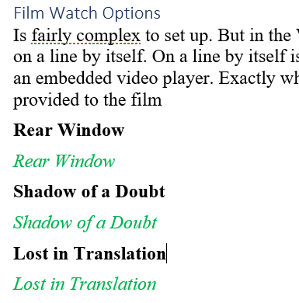

Figure - Film Watch Options in Word

### What is looks link on the Web

Each film is represented differently depending on if and how the video is available. For example, the films in Figure 16 are represented as follows.

### Rear Window

In this example, *Rear Window* was available via the Kanopy service. Kanopy provides a link, but not an easily calculated embeddable video player. Hence Figure 17 shows the bolded normal text of the film name (which was written in the Word document shown in Figure 16) and then a rounded box that contains the film name and a message with a link to Kanopy where the film can be viewed.

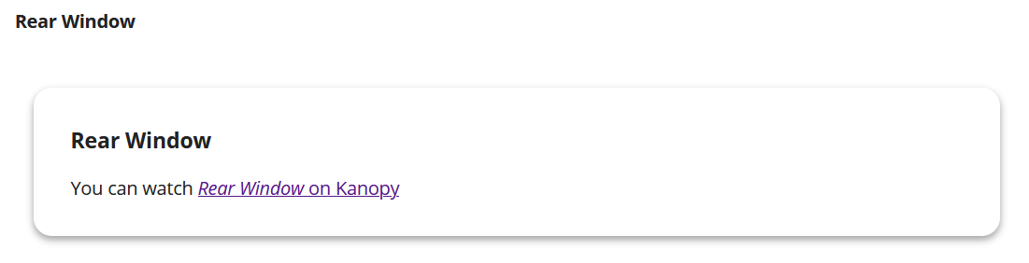

Figure - "Rear Window" as shown on the web

### Shadow of a Doubt

*Shadow of a Doubt* is available on the Internet Archive, which provides an embeddable video player. Hence, Figure 18 shows the film name (the bolded text in the Word doc) and the embeddable video player. With the movie ready to play.

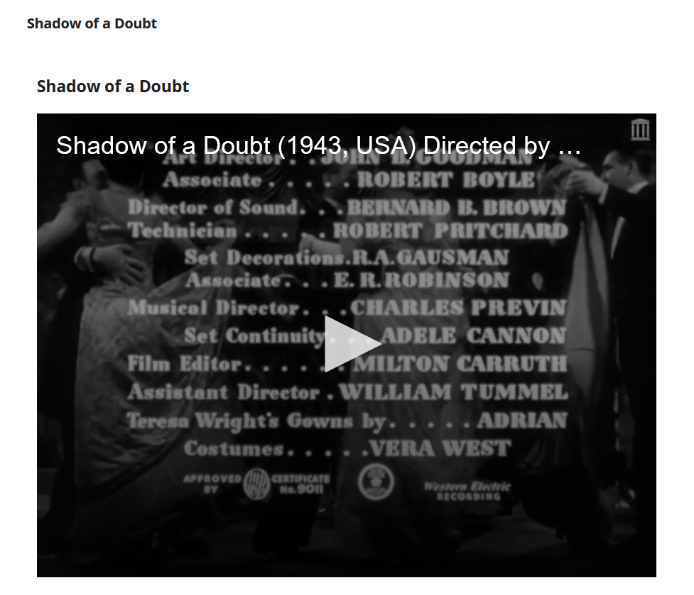

Figure - "Shadow of a Doubt" as shown on the Web

### Lost in Translation

Figure 19 illustrates when a film was not available. No URL was provided. As a default the Film Watch Options will generate a link to a search on the website <https://justwatch.com/au>. This website provides a service that searches all the available online sources of film and TV (e.g. streaming services). This allows the student to discover if they can source the film themselves.

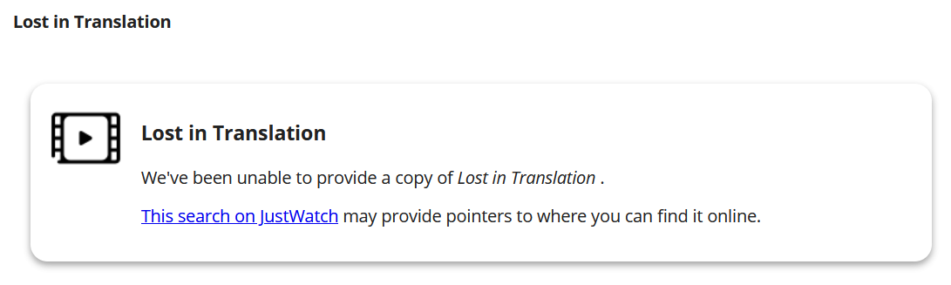

Figure - "Lost in Translation" as shown on the web

## How to do it

This process is reasonably complex and still under development. [Ask David Jones](mailto:d.jones6@griffith.edu.au) for assistance.

**Griffith University Specific**

Some of the following information is Griffith University specific. Though it can be used at other institutions, there is a bit more work to do.

### Create and maintain a “film availability” spreadsheet

1. Download a copy of this [*film availability* spreadsheet](https://griffitheduau-my.sharepoint.com/:x:/g/personal/d_jones6_griffith_edu_au/Ed9RLqTcWG5Fk_Lqj0yGuM0Bm93BLnzKphfDGB7PBpcZ6A?e=zZwQ8U).
2. Save your copy to a network drive (e.g. OneDrive, SharePoint).
3. Maintain a list of all the films used, including if and how they are available online.

### Convert the spreadsheet to a JSON file

This [online CSV to JSON service](https://csvjson.com/csv2json) does a good job. To use it

1. Select and upload your CSV file.
2. In the *Options* for conversion select the **Hash** option, rather than the *Array* option.
3. Hit *Convert* and download a copy of the JSON file.

Figure 20 is a simple example of converting a single line CSV file.

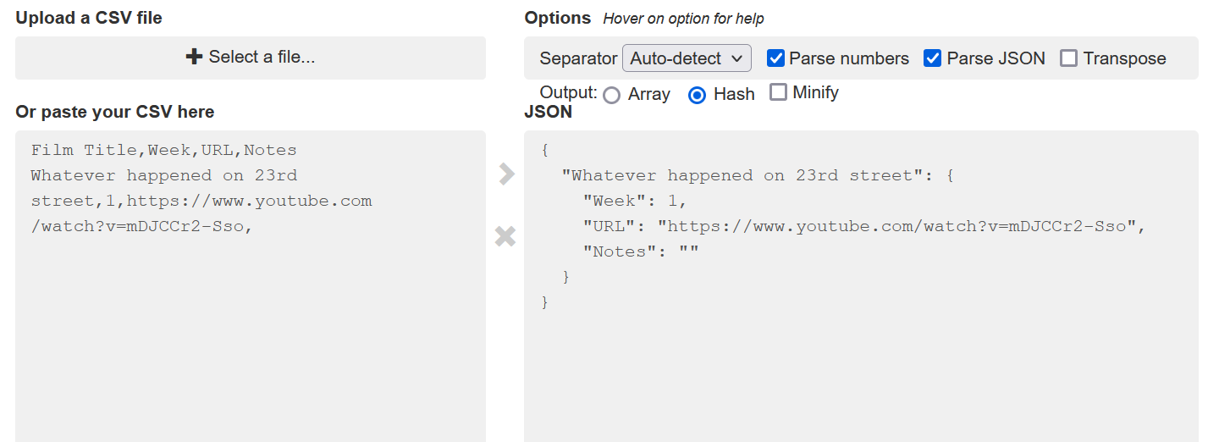

Figure - Sample CSV to JSON conversion

### Upload the JSON file to your course's content collection

The JSON file must be on the web and accessible. The best place for that is [the Blackboard Content Collection](https://intranet.secure.griffith.edu.au/computing/using-learning-at-griffith/staff/content/content-collection).

Obtain a permanent URL for the file you uploaded.

### Modify each Blackboard page using *film watch options*

Add a web link named *film watch options data* that is the permanent URL for the JSON file.

The Content Interface takes over from here.